Parallel and Distributed Computing

CSE4001

Fall Semester 2020-21

Lab Assignment 7/ Lab CAT

**ISHAAN OHRI**

**18BCE0265**

**Aim:**

Setup computational cluster with MPI.

**Source Code/ Execution:**

**TRIED ON STAND ALONE MACHINE:**

Tried using Homebrew to install openssh-server, but throws error on MacOS.

sudo apt-get install openssh-server

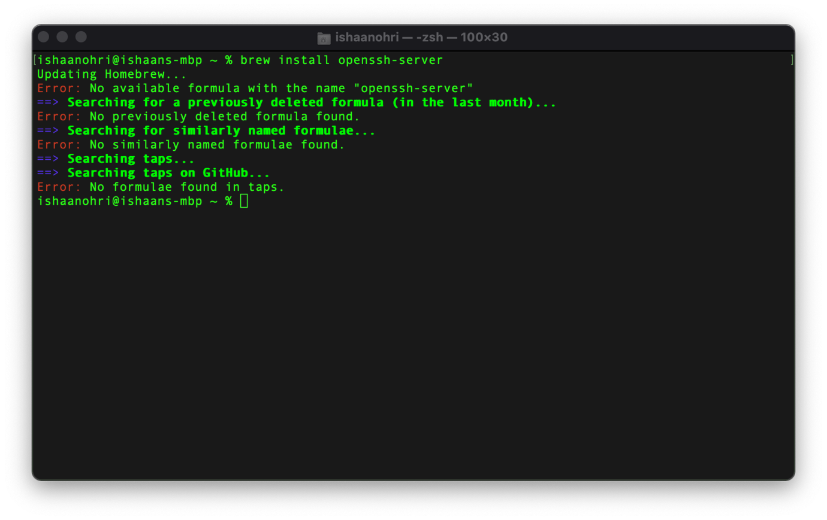

**TRIED ON VM ON GCP:**

sudo apt-get install openssh-server

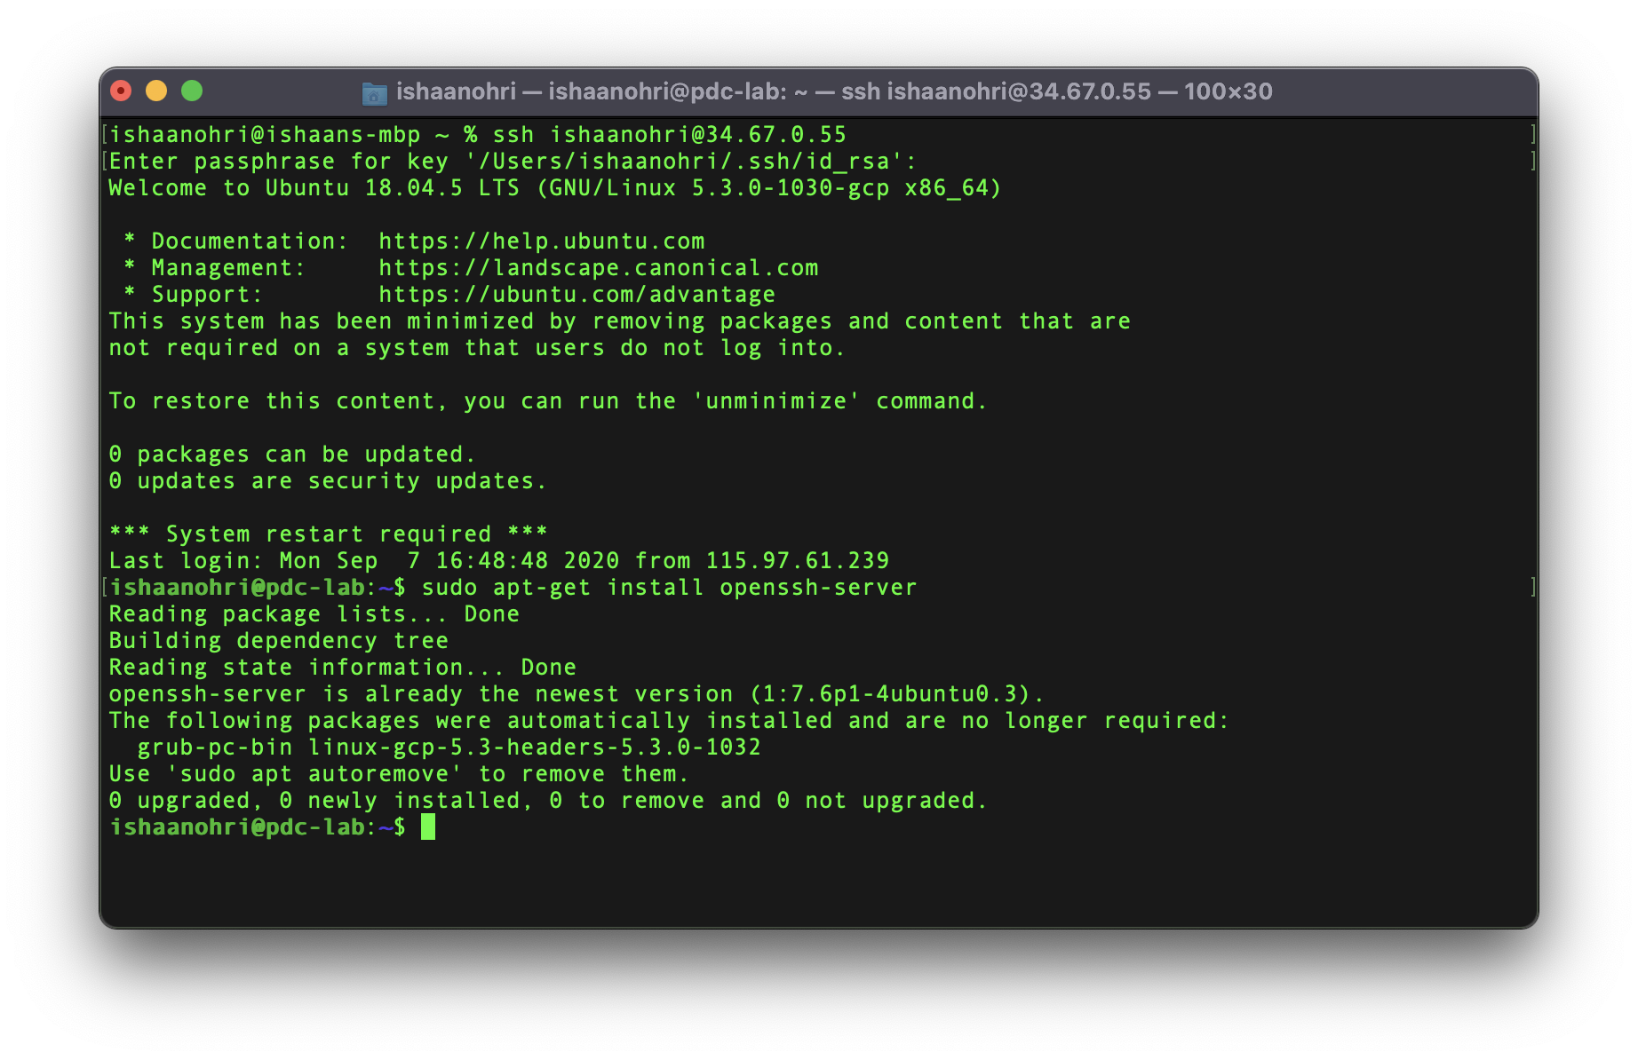

sudo apt-get install build-essential

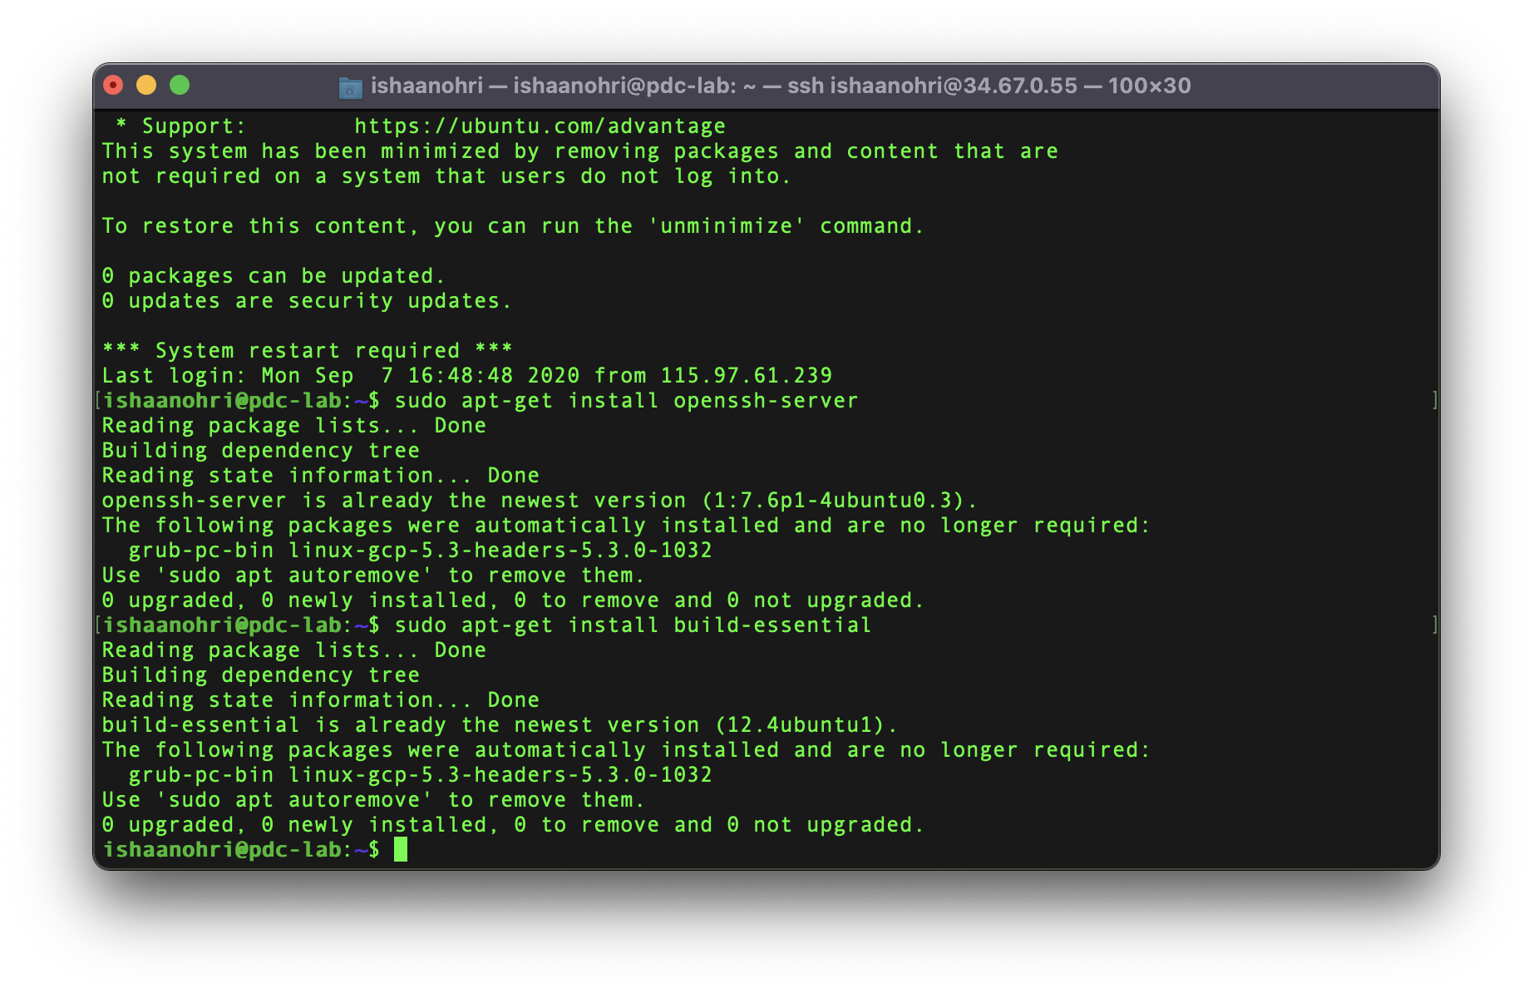

vim /etc/network/interfaces

The file is empty

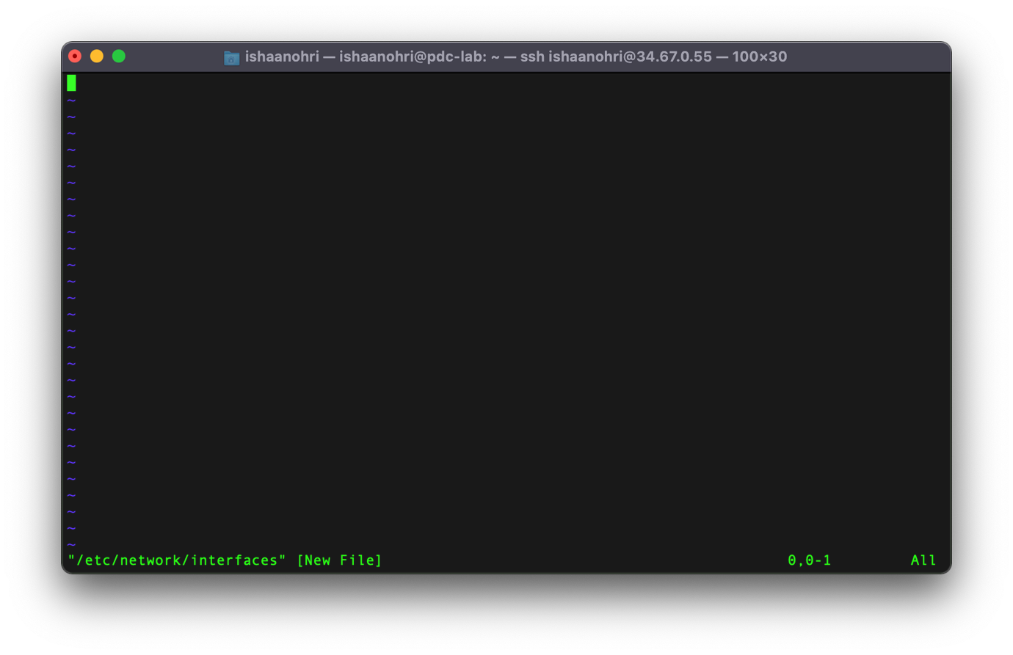

sudo apt-get install dnsmasq

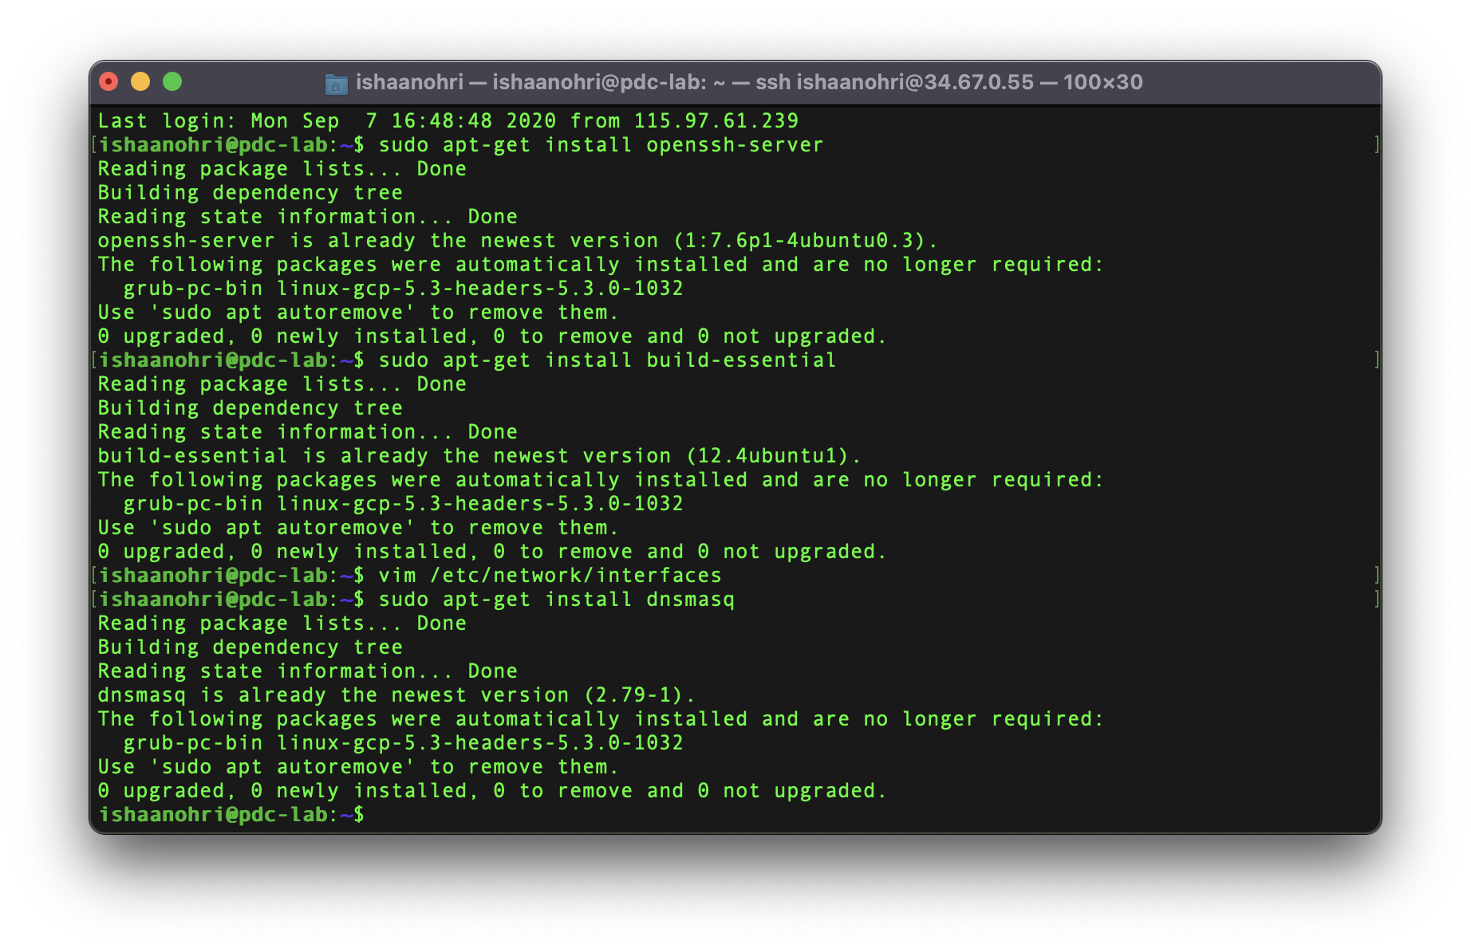

vim /etc/dnsmasq.conf

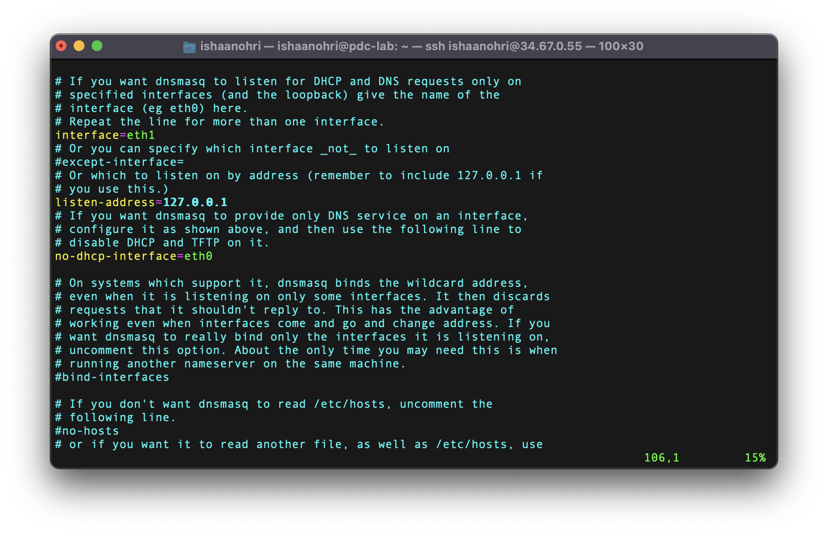

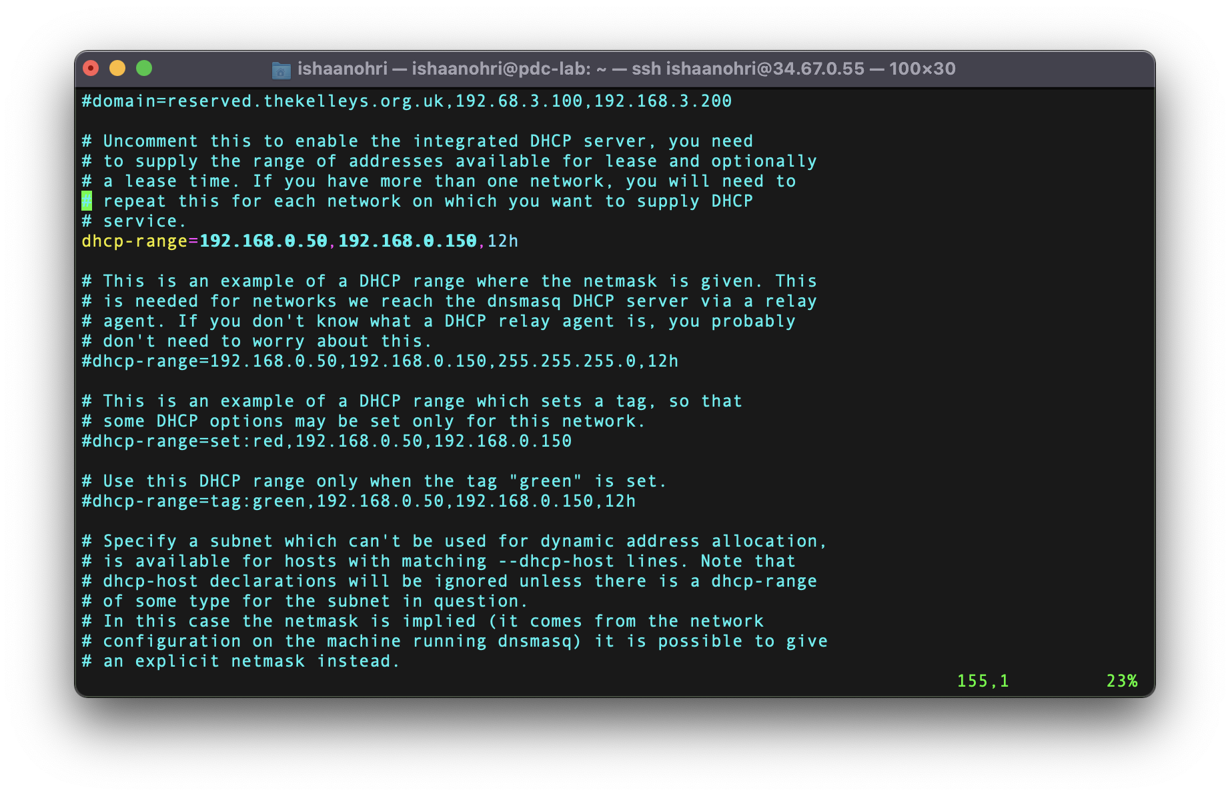

sudo service networking restart

Error on last line.

Failed to restart networking.service: Unit networking.service not found.

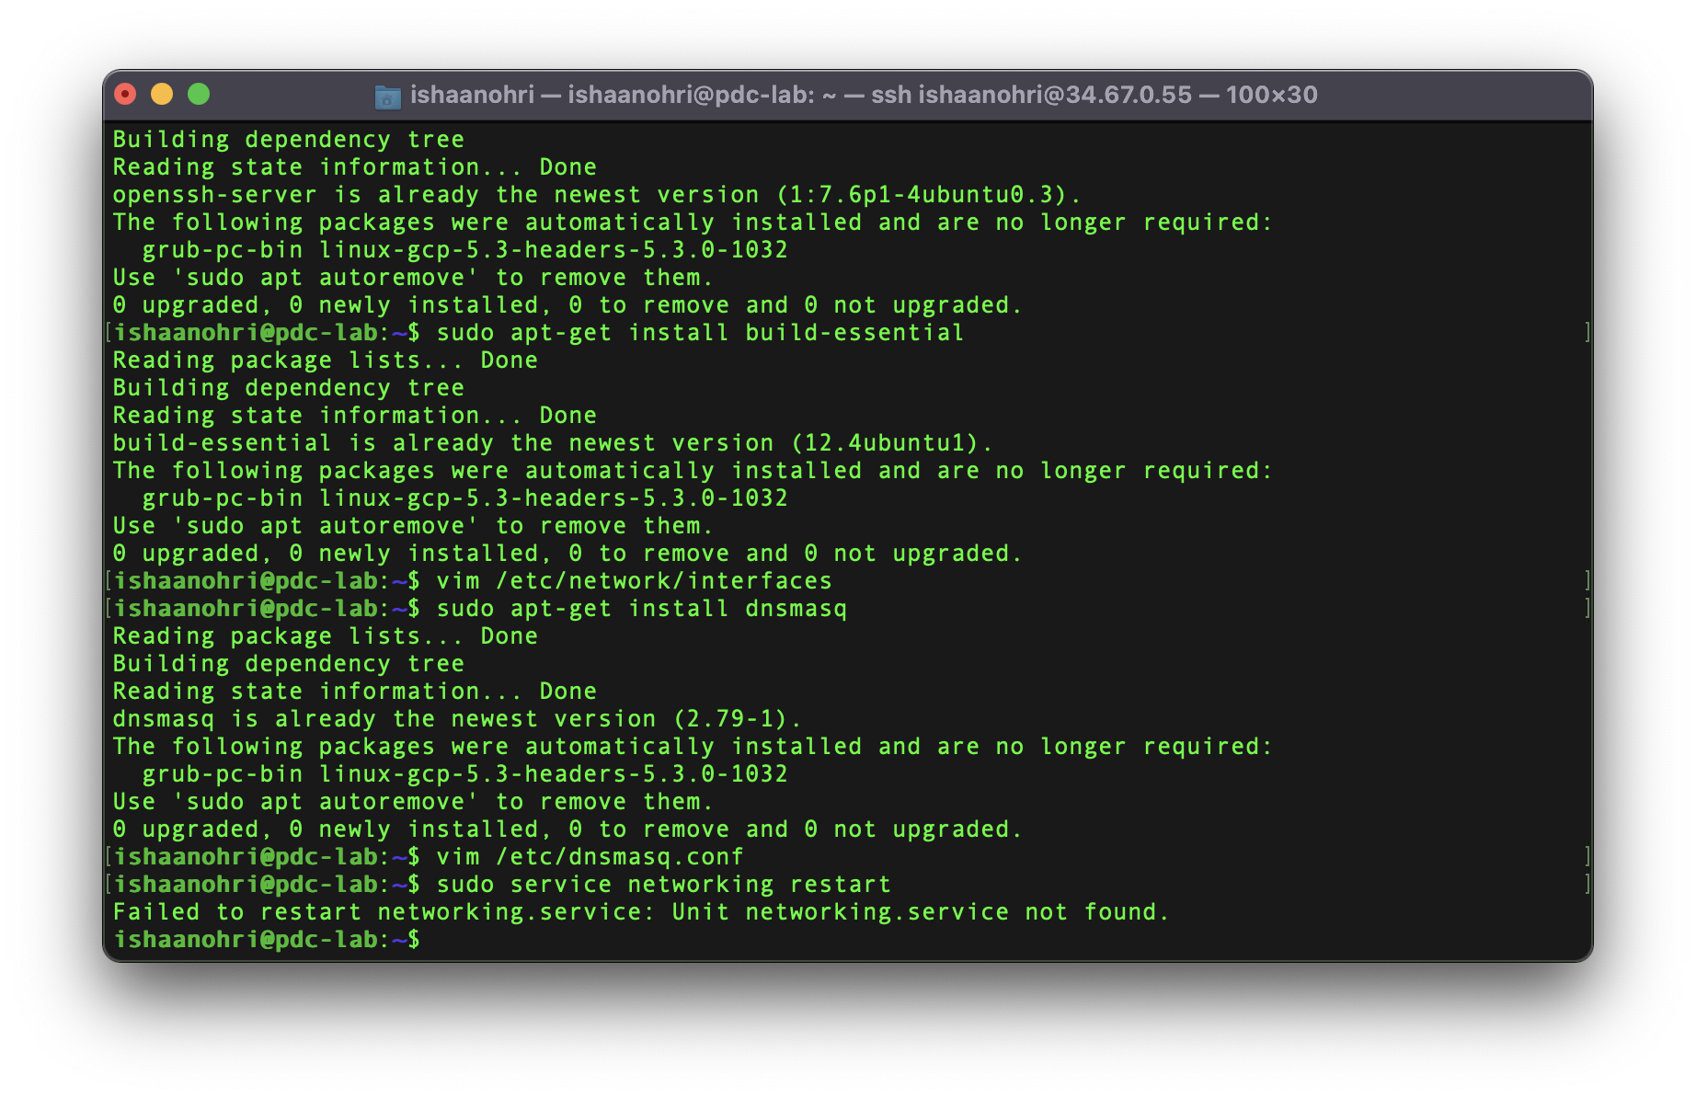

**Result:**

After executing on the two devices, I understood that on MacOS, a user cannot interact with the network card or other such modules because of Firewall restrictions because of security restrictions.

While on the GCP machine, as it is a virtual machine, it does not have a network card or such modules and therefore such commands cannot be executed.

Network card only exists on a stand-alone machine.

The question on VTop also mentions MPI_Send() and MPI_Recv() for Assignment 7, therefore I have attached the code below:

**Code:**

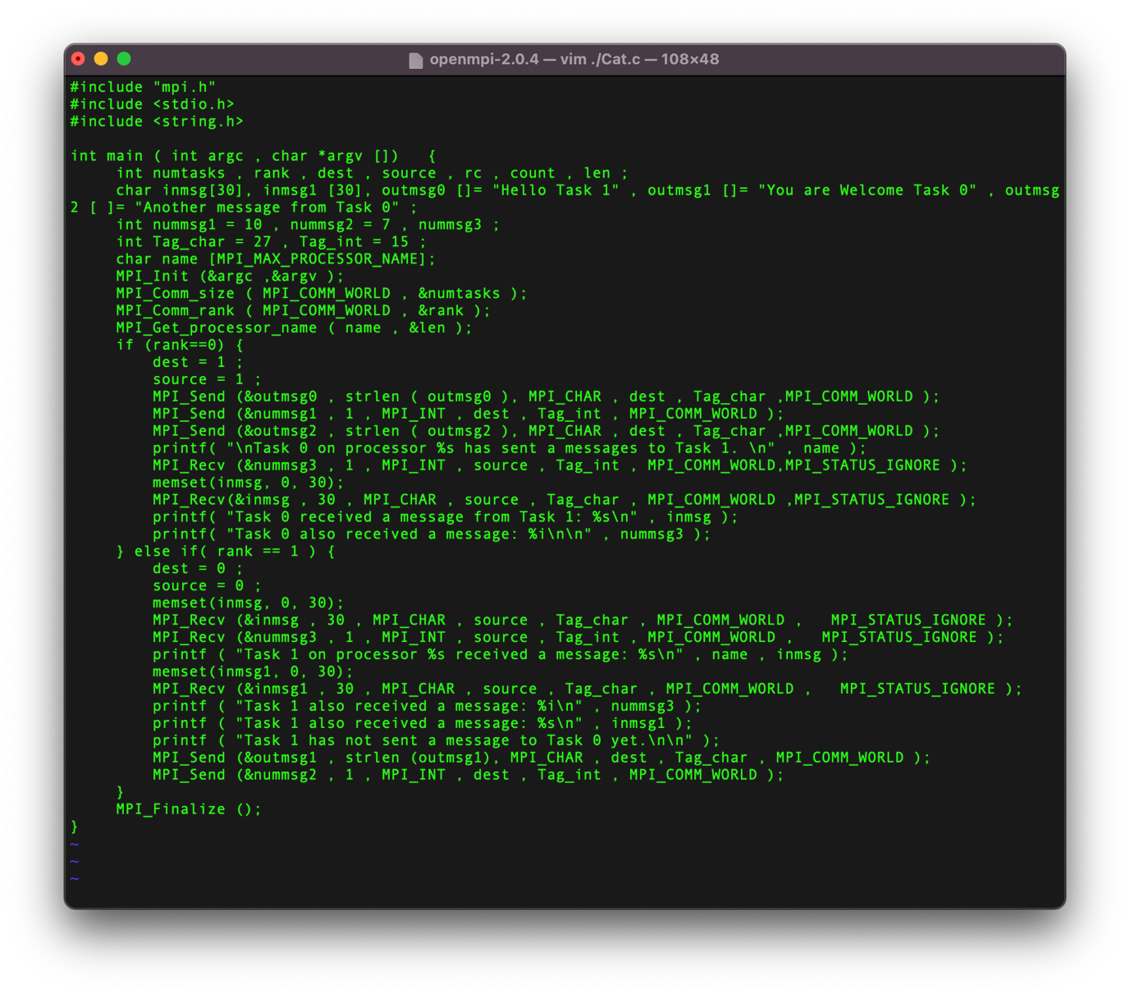

**Execution:**